https://github.com/MarquiseSlaughter/Mobile-Web-Application-Development/tree/master/Module_04/Project

http://mobilewebappvirtualmachine.centralus.cloudapp.azure.com/home/mobilewebappvirtualmachine/Mobile-Web-Application-Development/Module_04/Project/index.html

sftp://mobilewebappvirtualmachine@mobilewebappvirtualmachine.centralus.cloudapp.azure.com/home/mobilewebappvirtualmachine/Mobile-Web-Application-Development/Module_04/Project/index.html

**General Navigation**

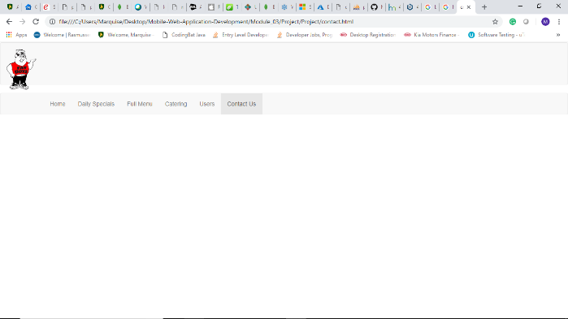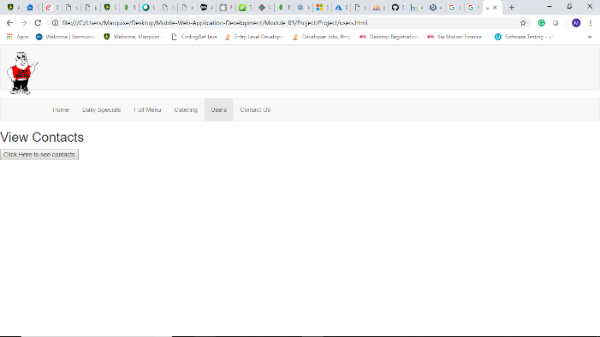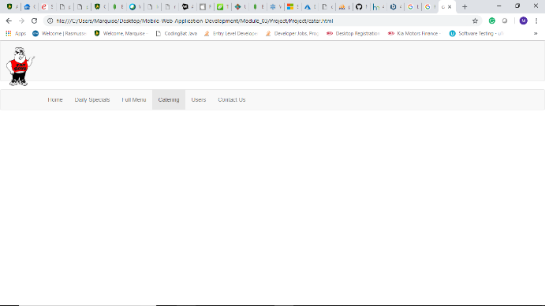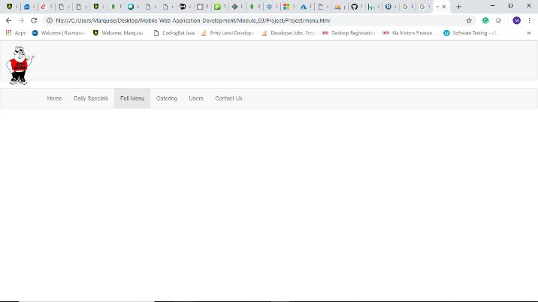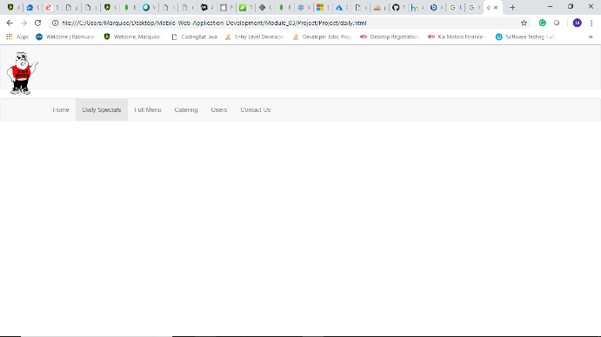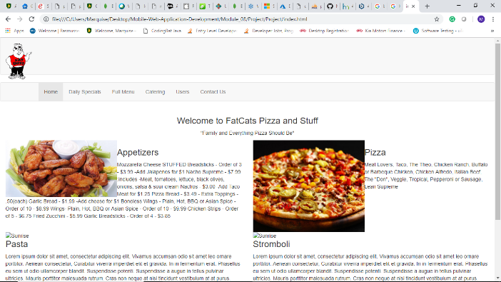

**Different Size Navigation**

